**ADARSH SANSKAR JUNIOR COLLEGE**



**Project Report on**

**“ICAD”**

**2018-2019**

**Guided By**

**Sanjay Chauhan**

**Submitted By**

**Mayank Sahu**

**CERTIFICATE**

CERTIFIED THAT THIS REPORT HAS BEEN SUBMITTED BY

(**Mayank Sahu**) STUDENT OF BIFOCAL (COMPUTER SCIENCE)

FOR PROJECT WORK PRESCRIBED BY MAHARASTRA STATE BOARD FOR THE PROJECT –“ICAD”

MOROVER THAT I HAVE INSTRUCTED/GUIDED FOR THE SAID WORK FROM TIME TO TIME THAT THE SAID WORK HAS BEEN ASSESSED ME AND THAT I AM SATISFIED WITH THE SAME

**Sanjay Chauhan Mrs. PritiSanyal**

**(Subject Teacher) (Principal)**

**INDEX**

1.INTRODUCTION

2.OBJECTIVES

3.FUTURE SCOPE OF PROJECT

4.SYSTEM FLOW CHART

5.SOFTWARE SPECFICATION

6.SOURCE CODE

7.SCREENSHOTS

8.LIMITATION

9.BIBLIOGRAPHY

**INTRODUCTION**

The website **“ICAD”** is based on HTML which is used to by users to get the information about the ICAD Institutes across India. The webpage shows all the important information for the new students who want to join it the webpage contain news, admissionsdetails, gallery and contact information which helps the users to get necessary information about the institute.

**OBJECTIVES**

* Providing quality content on website
* Adding new information
* Establishing trust with people
* Marketing the Institute

**FUTUTRE SCOPE OF PROJECT**

* To involve the correct people
* Identify the limitations
* Work on improvements

**SYSTEM FLOW CHART**

The main page of website shows the news bulletins that include the current results and selections. Main page also contain the a word of welcome and every page include the link to every other pages i.e. home page contain link to admission page, gallery page and contact page .Following system flow chart describes the system :

Home Page

Gallery Page

Admission Page

Contact Page

**SOFTWARE SPECIFICATION**

* Processor (CPU) with 2GHz frequency or above.
* A minimum of 2GB RAM
* Operating System: Windows 7,8 or 10 or MacOSX
* Browsers to run websites like chrome, Mozilla, Internet Explorer or safari for mac.

**SOURCE CODE**

1)Index.html

<!DOCTYPE html>

<html lang="en">

<head>

<meta charset="UTF-8">

<title>ICAD|Home Page</title>

</head>

<body style="background-color:#292929">

<br><br>

<center><a href="index.html"><imgsrc="images/logopng.png" alt="" height="100px"></a></center>

<br>

<table>

<tr>

<td width="70%">

<div style="background-color:#c68d4a">

<center><font color="white" size="6">ICAD Bulletin</font></center>

<hr>

<marquee behavior="scroll" direction="up">

<ul type="square">

<font color="white">

<li><p>Massive 460+ ICADians qualified JEE-MAIN 2017. The highest selection in Vidarbha.</p></li>

<li><p>1st Amravati District Topper Mithila Sanor (JEE Score 235) 3rd Amravati District Topper Deepshri Sharma (JEE Score 202) and 5th Amravati District Topper (JEE Score 198) are ICADians.</p></li>

<li><p>45 ICADians secured 90% + in boards.</p></li>

<li><p>3 ICADians in Top 1000 AIR.</p></li>

</font>

</ul>

</marquee>

</div>

</td>

<td width="30%">

<ul>

<a href="index.html" style="text-decoration: none"><font color="white" size="5">Home</font></a>

<br><br>

<a href="admission.html" style="text-decoration: none"><font color="white" size="5">Admissions</font></a>

<br><br>

<a href="gallery.html" style="text-decoration: none"><font color="white" size="5">Gallery</font></a>

<br><br>

<a href="contact.html" style="text-decoration: none"><font color="white" size="5">Contact Us</font></a>

<br><br>

</ul>

</td>

</tr>

</table>

<center>

<h1><font face="Comic sans MS" color="#c68d4a">A WORD OF WELCOME</font></h1></center>

<div>

<p><font size="4" face="Verdana" color="white">Welcome to ICAD School of Learning! We realize that this is the time of excitement and hope for a better future. We assure you that you are at the right place to pursue your dream. <br>You are entering the entire new academic system that you have encountered before. You will experience the change in study pattern and the need of more efforts to surpass the challenges posed by one of the most competitive examination of the world.

<br>Best and experienced faculty of the field, disciplined and well trained administrative staff, result oriented atmosphere and most efficient system of India you will get in ICAD School of Learning. <br>It’s a Challenge, It’s an Experience, It’s an Opportunity <br><br>COME, FEEL IT FOR YOURSELVES!

<br>&nbsp;&nbsp;&nbsp;<b>Happy Learning!</b></font></p>

<hr>

<center><font color="#c68d4a" size="4">&#64;2018,All rights resereved</font></center>

</div>

</body>

</html>

2)Admission.html

<!DOCTYPE html>

<html lang="en">

<head>

<meta charset="UTF-8">

<title>ICAD|Admissions</title>

</head>

<body style="background-color:#292929">

<br><br>

<center><a href="index.html"><imgsrc="images/logopng.png" alt="" height="100px"></a></center>

<br>

<table>

<tr>

<td width="70%">

<div style="background-color:#c68d4a">

<center><font color="white" size="6">ICAD Bulletin</font></center>

<hr>

<marquee behavior="scroll" direction="up">

<ul type="square">

<font color="white">

<li><p>Massive 460+ ICADians qualified JEE-MAIN 2017. The highest selection in Vidarbha.</p></li>

<li><p>1st Amravati District Topper Mithila Sanor (JEE Score 235) 3rd Amravati District Topper Deepshri Sharma (JEE Score 202) and 5th Amravati District Topper (JEE Score 198) are ICADians.</p></li>

<li><p>45 ICADians secured 90% + in boards.</p></li>

<li><p>3 ICADians in Top 1000 AIR.</p></li>

</font>

</ul>

</marquee>

</div>

</td>

<td width="30%">

<ul>

<a href="index.html" style="text-decoration: none"><font color="white" size="5">Home</font></a>

<br><br>

<a href="admission.html" style="text-decoration: none"><font color="white" size="5">Admissions</font></a>

<br><br>

<a href="gallery.html" style="text-decoration: none"><font color="white" size="5">Gallery</font></a>

<br><br>

<a href="contact.html" style="text-decoration: none"><font color="white" size="5">Contact Us</font></a>

</ul>

</td>

</tr>

</table>

<br>

<center><h1><font face="Comic sans MS" color="#c68d4a">A D M I S S I O N A N D S C H O L A R S H I P</font></h1></center>

<h3 style="color: #c68d4a">CPA (COMPETITIVE POTENTIAL ASSESSMENT) TEST</h3>

<p style="color: white">&nbsp;&nbsp;&nbsp;&nbsp;CPA is a unique test which verifies your analytical skills acquired at high school level. CPA is designed in such a way that the conceptual <br>&nbsp;&nbsp;&nbsp;&nbsp;&nbsp;&nbsp;&nbsp;&nbsp;&nbsp;&nbsp;&nbsp;&nbsp; understanding of the subject knowledge is finely tested. The popularity of CPA is in its simple form, which tests the complex concepts<br>&nbsp;&nbsp;&nbsp;&nbsp;&nbsp;&nbsp;&nbsp;&nbsp;&nbsp;&nbsp;&nbsp;&nbsp; in the most lucid and straight – forward way. A high performance in CPA truly reflects the conceptual clarity of the student.</p>

<h3 style="color: #c68d4a">ADMISSIONS & SCHOLARSHIPS</h3>

<p style="color: white">&nbsp;&nbsp;&nbsp;&nbsp;Aspiring students are admitted at ICAD based on their performance in ICAD’s admission & scholarship (CPA) test. Prospective ICADians are eligible<br>&nbsp;&nbsp;&nbsp;&nbsp;&nbsp;&nbsp;&nbsp;&nbsp;&nbsp;&nbsp;&nbsp;&nbsp; for 10- 100% waiver in their tuition fees based on their performance in ICAD’s Scholarship & Admission Competitive Potential Assessment (CPA) Test.</p>

<hr>

<center><font color="#c68d4a" size="4">&#64;2018,All rights resereved</font></center>

</body>

</html>

3)Gallery.html

<!DOCTYPE html>

<html lang="en">

<head>

<meta charset="UTF-8">

<title>ICAD|Gallery</title>

</head>

<body style="background-color:#292929">

<br><br>

<center><a href="index.html"><imgsrc="images/logopng.png" alt="" height="100px"></a></center>

<br>

<table>

<tr>

<td width="70%">

<div style="background-color:#c68d4a">

<center><font color="white" size="6">ICAD Bulletin</font></center>

<hr>

<marquee behavior="scroll" direction="up">

<ul type="square">

<font color="white">

<li><p>Massive 460+ ICADians qualified JEE-MAIN 2017. The highest selection in Vidarbha.</p></li>

<li><p>1st Amravati District Topper Mithila Sanor (JEE Score 235) 3rd Amravati District Topper Deepshri Sharma (JEE Score 202) and 5th Amravati District Topper (JEE Score 198) are ICADians.</p></li>

<li><p>45 ICADians secured 90% + in boards.</p></li>

<li><p>3 ICADians in Top 1000 AIR.</p></li>

</font>

</ul>

</marquee>

</div>

</td>

<td width="30%">

<ul>

<a href="index.html" style="text-decoration: none"><font color="white" size="5">Home</font></a>

<br><br>

<a href="admission.html" style="text-decoration: none"><font color="white" size="5">Admissions</font></a>

<br><br>

<a href="gallery.html" style="text-decoration: none"><font color="white" size="5">Gallery</font></a>

<br><br>

<a href="contact.html" style="text-decoration: none"><font color="white" size="5">Contact Us</font></a>

<br><br>

</ul>

</td>

</tr>

</table>

<br>

<imgsrc="images/Akola.JPG" alt="" height="400px">

<imgsrc="images/Amravati.JPG" alt="" height="400px">

<imgsrc="images/East%20-%201.JPG" alt="" height="400px">

<imgsrc="images/East-2.JPG" alt="" height="400px">

<imgsrc="images/HO-2015.JPG" alt="" height="400px">

<hr>

<center><font color="#c68d4a" size="4">&#64;2018,All rights resereved</font></center>

</body>

</html>

4)Contact.html

<!DOCTYPE html>

<html lang="en">

<head>

<meta charset="UTF-8">

<title>ICAD|Contact</title>

</head>

<body style="background-color:#292929">

<br><br>

<center><a href="index.html"><imgsrc="images/logopng.png" alt="" height="100px"></a></center>

<br>

<table>

<tr>

<td width="70%">

<div style="background-color:#c68d4a">

<center><font color="white" size="6">ICAD Bulletin</font></center>

<hr>

<marquee behavior="scroll" direction="up">

<ul type="square">

<font color="white">

<li><p>Massive 460+ ICADians qualified JEE-MAIN 2017. The highest selection in Vidarbha.</p></li>

<li><p>1st Amravati District Topper Mithila Sanor (JEE Score 235) 3rd Amravati District Topper Deepshri Sharma (JEE Score 202) and 5th Amravati District Topper (JEE Score 198) are ICADians.</p></li>

<li><p>45 ICADians secured 90% + in boards.</p></li>

<li><p>3 ICADians in Top 1000 AIR.</p></li>

</font>

</ul>

</marquee>

</div>

</td>

<td width="30%">

<ul>

<a href="index.html" style="text-decoration: none"><font color="white" size="5">Home</font></a>

<br><br>

<a href="admission.html" style="text-decoration: none"><font color="white" size="5">Admissions</font></a>

<br><br>

<a href="gallery.html" style="text-decoration: none"><font color="white" size="5">Gallery</font></a>

<br><br>

<a href="contact.html" style="text-decoration: none"><font color="white" size="5">Contact Us</font></a>

<br><br>

</ul>

</td>

</tr>

</table>

<center>

<h2 style="color: #c68d4a">C O N T A C T U S</h2>

<br><center>

<p style="color: white">Corporate Head Office & Study Center:

ICAD Heights (West Nagpur)

21, Tilak Nagar, Opp. Basket Ball Ground

Nagpur - 440010.

Maharashtra State, INDIA <br><br>

+91-9823037090

<br><br> contact@icadiit.com</p>

</center>

</center>

</body>

</html>

**Screenshots**

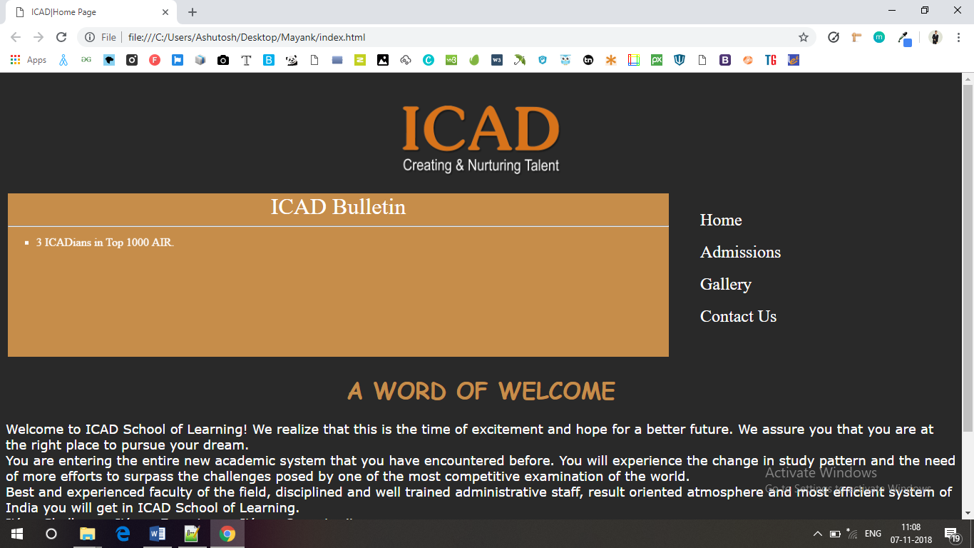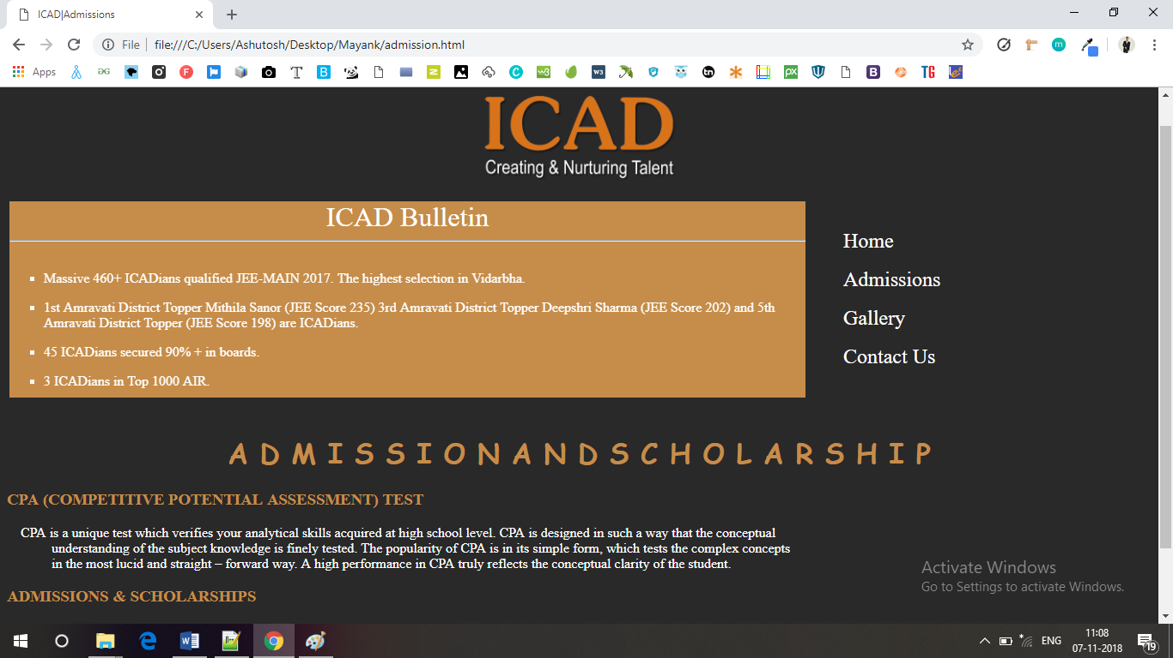

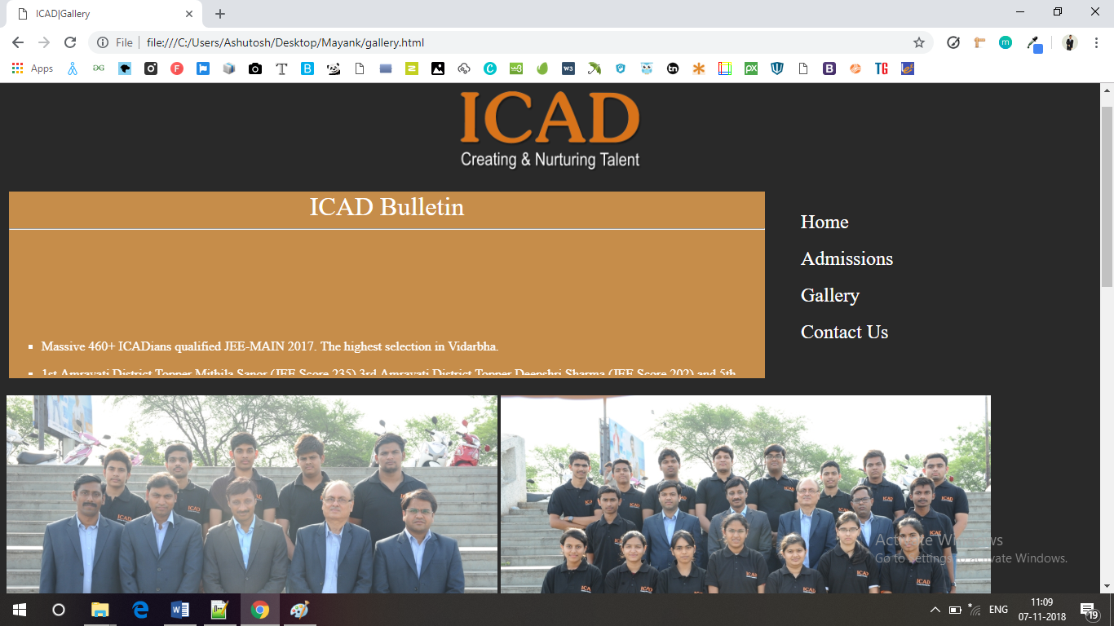

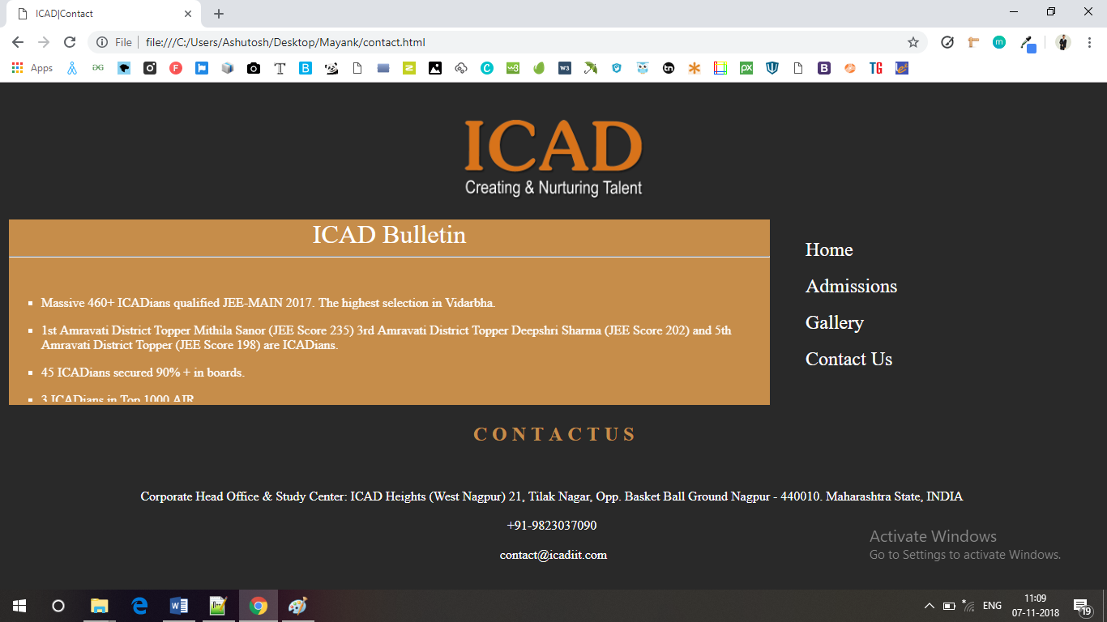

**LIMIATIONS**

* Website don’t contain form page for user for any inquires.
* Look of website need to be improved.
* Marquee tag used have limitations problem with browser.

**BIBLIOGRAPHY**

* “A Textbook of Computer Science” by Dr.PrakashKhanale –Nikita Publication –Latur
* Google Chrome